Installation guide for 71-72Chevy and GMC trucks

1 Remove the ash tray from the dash.
Mark a position to drill the wire exit hole at the back of the tray.
Position isn’t critical but stay on the flat section, so the grommet sits flush.
Drill a ¼” (6mm) hole for the wire exit hole on the back of the tray. Remove sharp edges A larger drill bit works well for this and install the grommet.
Softening the grommet in hot water will make this easier.

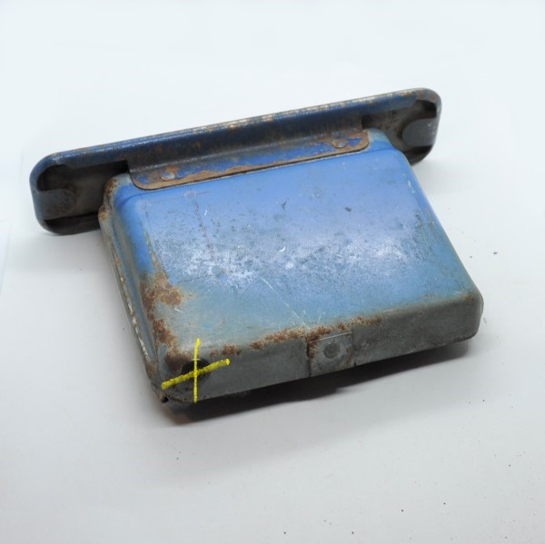
2 On the stubber lay out and drill the hole positions as shown. They should be at the mid point on the second and seventh slot. Drill size is 1/8” or 3.5mm for the two 2mm machine screws.

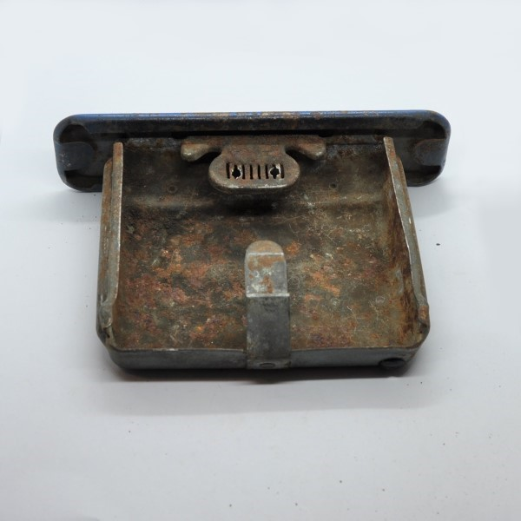

3 remove the 3mm screws from the charger and thread the wire through the grommet. Then position the charger so the screw holes line up with the holes in the stubber. Check to see if the back edge of the charger touches the base of the ashtray. If not, bend down the stubber a little. It’s important for the charger to sit as low as possible for smooth operation of the ashtray slide.

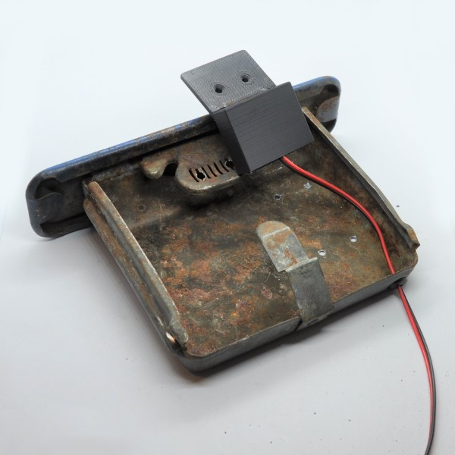

4 Once the height is set, insert the two screws and just nip them tight. Too much force and the stubber will be deformed.

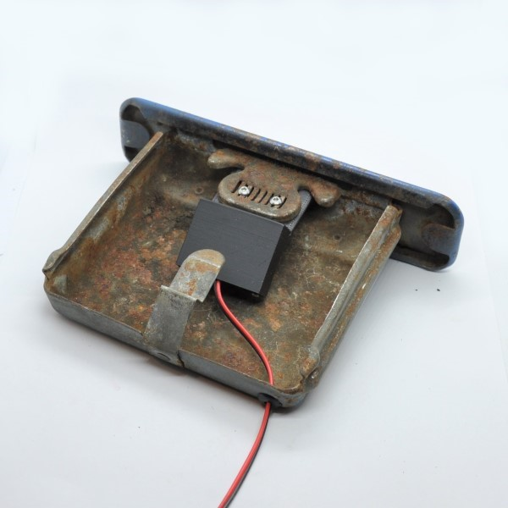

5 Plug in your phone and go for a cruise!

